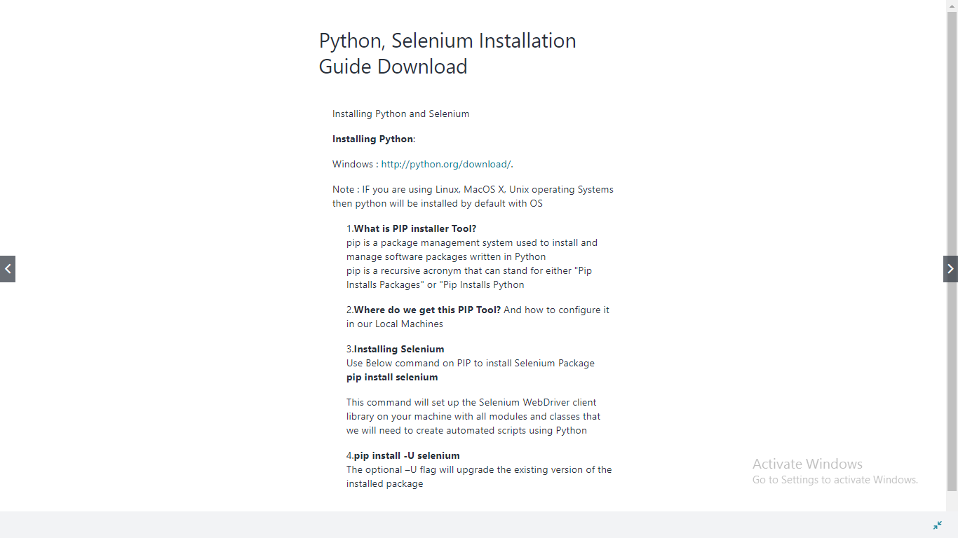

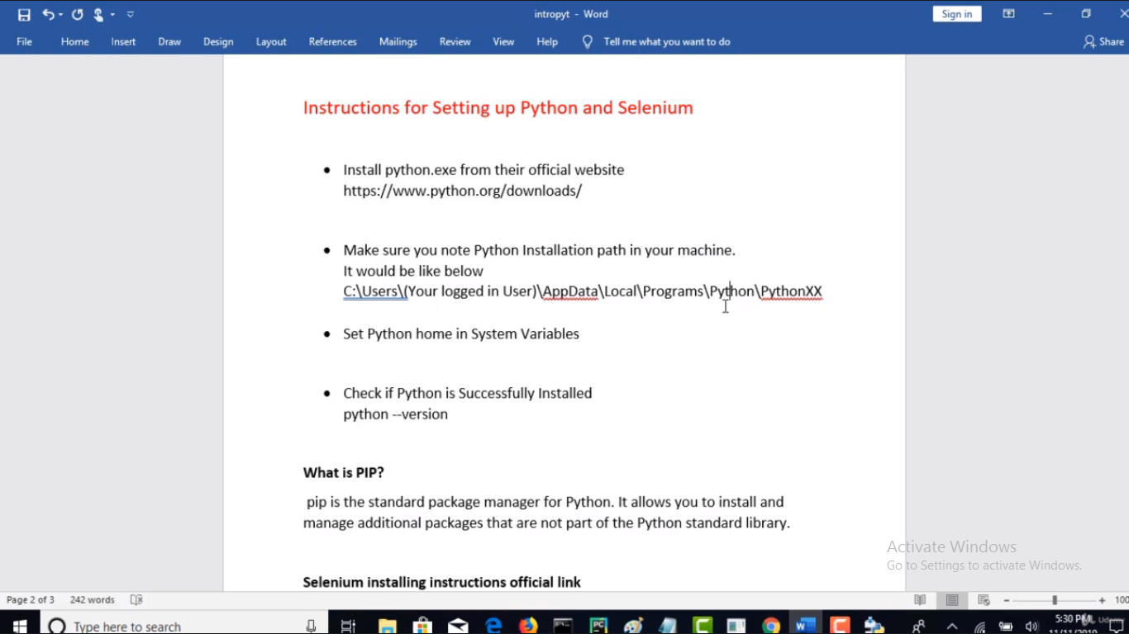

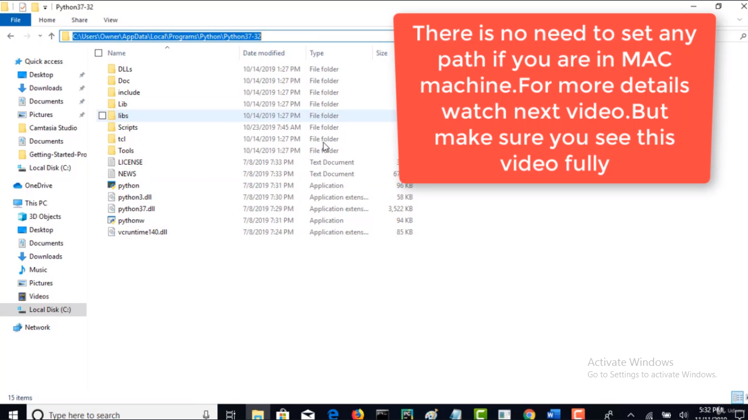

* Download and install Python latest version.
* Set the Path variable of python.

1. Search for Edit the system environment variables > Environment variables > Click on Path variable > new > Provide “C:\Users\HP\AppData\Local\Programs\Python\Python38-32” and also “C:\Users\HP\AppData\Local\Programs\Python\Python38-32\Scripts”. > OK

* To check we have done everything perfect open command prompt > python –version



